**UNIVERSITY OF HERTFORDSHIRE**

**Faculty of Science Technology and the Creative Arts**

**Modular MSc Honours in Computer Science**

**7WCM0031 Software Engineering MSc Project**

**Extended Project Proposal**

**July 2015**

**Development of a distributed system for ‘MSc Properties’**

**Mr D L Edwards**

**Table of Contents**

Table of Contents…………………………………………………………………………………………………………………i

1 Aim……………………………………………………………………………………………………………………………………1

2 Objectives………………………………………………………………………………………………………………………….1

2.1 Core Objectives…………………………………………………………………………………………………..1

2.2 Advanced Objectives…………………………………………………………………………………………..2

3 Background……………………………………………………………………………………………………………………….2

4 Methods/Methodology……………………………………………………………………………………………………..3

5 Project Plan……………………………………………………………………………………………………………………….3

6 Relation to Target Award…………………………………………………………………………………………………..8

7 Required resources and skills…………………………………………………………………………………………….9

8 Ethics Approval………………………………………………………………………………………………………………..10

9 Bibliography…………………………………………………………………………………………………………………….11

**Aim**

Development of a distributed system for ‘MSc Properties’.

Develop and implement a distributed system for ‘MSc Properties’ to manage their business data and meet the required functionality and performance desired by MSc Properties, ensuring it is maintainable, dependable, and usable. In doing this I will explore the different techniques that support program specification, design, validation and evolution of software.

**Objectives**

**Core Objectives**

Analyse ‘MSc Properties’ current business processes by week 5.

Complete literature search and review of existing data management systems, identifying the software engineering models, methodologies, tools and metrics used in the development process by week 12.

Set out functional and non-functional requirements for the development within the requirements document by week 9.

Ensure required resources are available for the entire project by week 9.

Carry out risk assessment by week 10.

Develop a suitable data management system model that meets the requirements defined by week 15.

Write test scripts to test the implementation of the system outlined in the development model by week 15.

Develop a suitable database to handle the business data and import dummy data into the database by week 16.

Develop a suitable application to handle the business processes and connect to the database to store the business data by week 24.

Develop a suitable search facility so users can search for information stored in the database, and should be implemented by week 24.

Develop reporting functionality so certain users can report on business performance indicators by week 24.

Develop a log in facility for users, allowing for restricted access, and to prevent unauthorised access and should be implemented by week 26.

Test the system using the test scripts created, ensuring the test results are above the acceptable failure rate defined in the requirements by week 33.

Develop and test a user manual by week 31.

Evaluate the project in a report to detail the entire development and outline what went well and what could have been done better by week 34.

**Advanced Objectives**

Develop a website to advertise services offered to potential customers/suppliers. Customers/Suppliers will be able to register and submit a service request through the website and should be implemented by week 26.

Develop document management facility that allows for documents to be stored electronically, and should be implemented by week 26.

Develop a home screen which provides a live feed of the tenancies and leases due to expire by week 26.

Develop a reset password facility, so users are able to reset their password if they have forgotten it allowing users to establish access to the system. This should be implemented by week 26.

**Background**

‘MSc Properties’ is a fictional estate agent with a number of sites nationwide across England. Due to recent legislation changes resulting in local councils being able to house homeless families outside of the local borough [25] and benefit caps [23] meaning families have to move out of their local borough due to not being able to afford local rents [25], ‘MSc Properties’ require the need to be able to transfer customers between sites, meaning the transfer of data across sites that could be 100’s of miles apart.

‘MSc’ Properties currently have a paper filing system, where customers and/or the landlords of properties fill out an application form to request a service from ‘MSc Properties’. Customers will have to provide their personal information, along with the properties they have an interest in letting. Landlords will have to provide their personal information, along with the property information for the property they would like managed. Part of the landlord/customer sign up process is to bring in a number of documents confirming their information, and once customers have agreed on a property to let, and once ‘MSc Properties’ have agreed to manage a property for a landlord, contracts will be drawn up and signed respectively and all documents stored on file.

‘MSc Properties’ currently advertise their property portfolio through pictures in their store windows for properties for that area, and store managers carry out a revenue monitoring exercise each month, going through each file for the store and carrying out budget monitoring and cash flow forecasting, along with reports for the months business activity. Also there is a staff hierarchy within ‘MSc Properties’ where specific tasks and responsibilities are assigned to certain staff roles meaning that not all staff can carry out each task due to privileges.

For this project I am going to develop a distributed system for ‘MSc Properties’ to create and manage their property portfolio and their customer accounts, as well as creating and managing both tenancies and rent accounts. This means that data can be stored on a server or locally and all the different sites of ‘MSc Properties’ will be able to access this data. The system will have a login facility to provide restricted access for users, and will also allow managers of ‘MSc Properties’ stores to manage their employee accounts. The system will also allow ‘MSc Properties’ managers to report on business data.

**Methods/Methodology**

This is a practitioner project, as it involves the development of a distributed system to address the requirements of ‘MSc Properties’. I will adopt a software model to structure the project, this will allow the project to be managed, and an example of a software model I may use is the waterfall model [4].

To assist me in designing the distributed system, I’m going to use the unified modelling language (UML) to develop diagrams which will allow me to virtualize the design of the structure, behaviour and interaction of the distributed system. When designing and implementing the distributed system I’m going to use programming techniques to ensure my program has high cohesion, strong encapsulation, and low coupling [10].

For the implementation of the distributed system, I will use more programming techniques such as remote method invocation (RMI) [26], this will allow me to develop a distributed system that can communicate between hosts and a server on the same or different networks. I will also use Java GUI frameworks such as AWT and Swing to develop the Java interface. I will also use JDBC or ORM to provide a common interface (API) to the MySQL database [27], allowing the distributed system to interact with the database. During the development I will use a concurrent version system to track the evolution of files in the development, allowing me to keep track of updates made and a rollback facility to go back to a previous working version if necessary.

To test my program source code I am going to use a number of testing strategies to ensure my program developed has no faults or errors at runtime and the program works as set out by the requirements. I am going to do unit testing and system testing with a combination of both black and white box testing strategy. This will allow me to test individual components as a single to ensure each of these work alone and find defects with my program source code as early as possible in the development, and also test the components as a group to ensure the components of my program work together as intended. To allow me to control the execution of my tests and compare actual outcomes against predicted outcomes, I am going to use a bug tracking and testing tool.

**Word count = 386**

**Project Plan**

As this is a large project, it is very important that I plan, monitor and manage the project smoothly from start to finish. I have used a Gantt chart, which provides a graphical illustration of the schedule of the project, broken down by project objectives, with completion dates for each objective, which will help me track the activities in the project and make changes to work being carried out if necessary. This tool will be used to manage my time and allow me to stay on schedule as there is a lot of tasks that need to be completed in a limited time frame. This is outlined in a software management article [5], where the article identifies “a recent update of the Chaos Report from the Standish Group, outlines a recipe for success that includes 10 items. The first three items are executive support, user involvement, and experienced project management.”, so project management is one of the 3 key factors to successful projects.

My project Gantt chart is below:

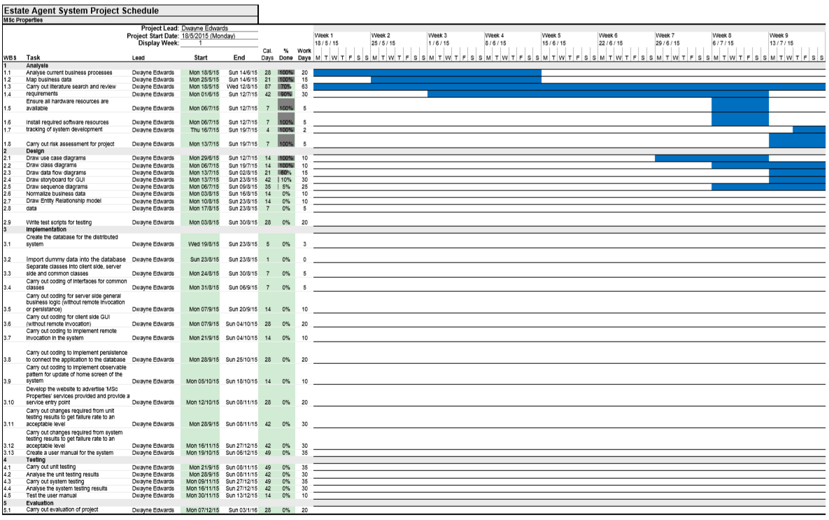

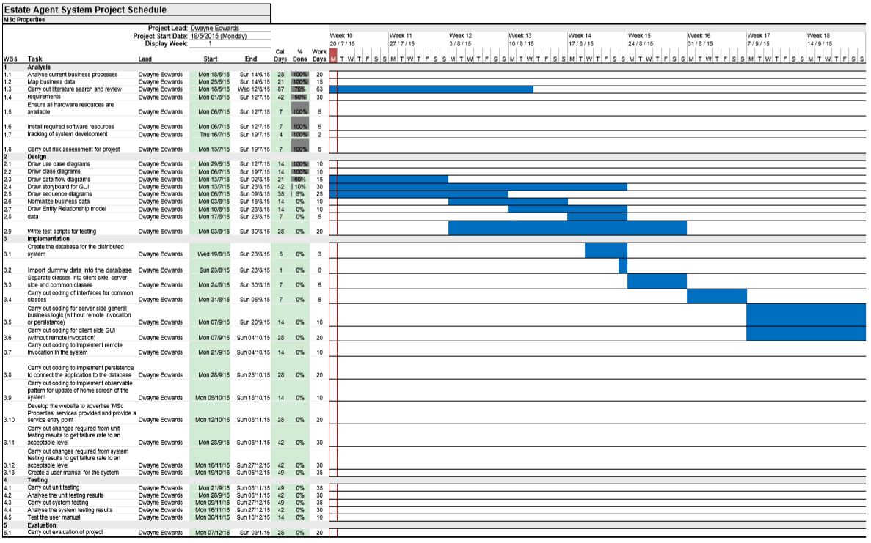

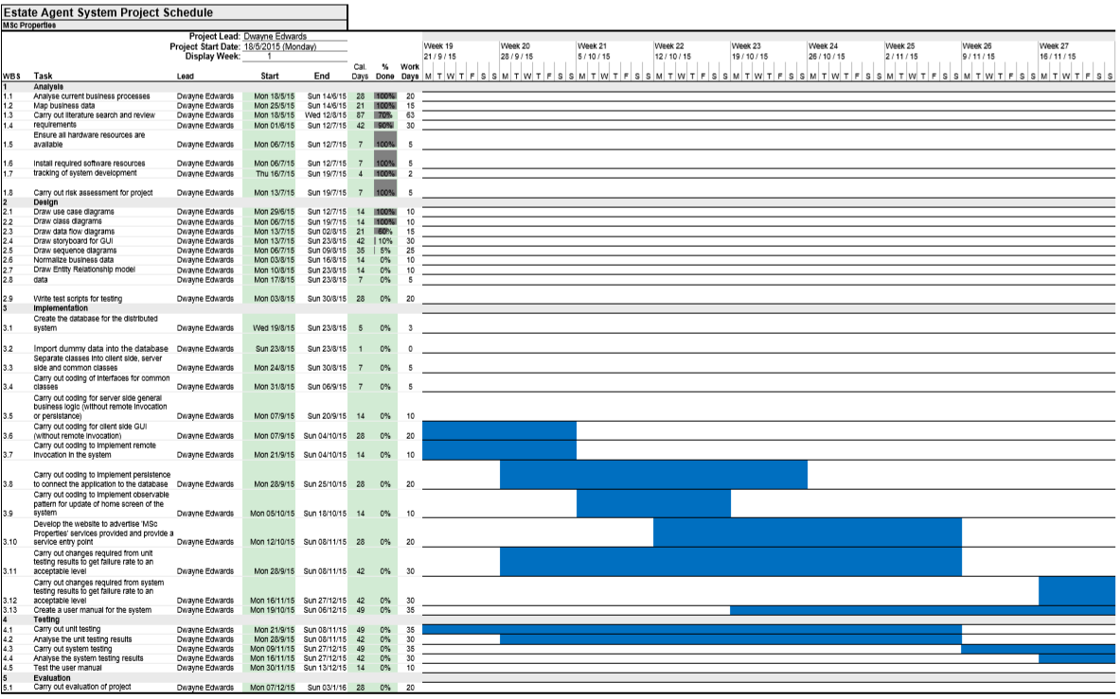

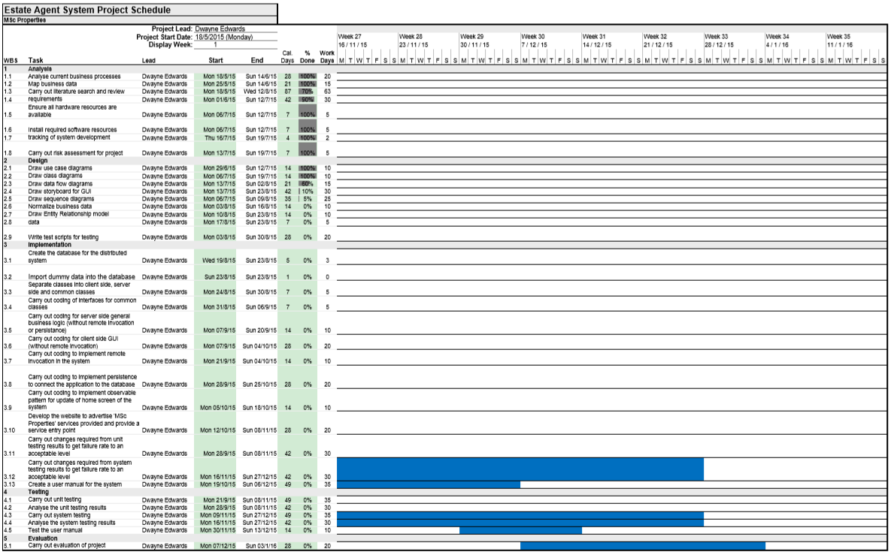

I am now going to explain how the project objectives will be completed by the project deadline date of 11 Jan 2015.

1. Write a project document outlining the details of the project, defining project objectives, scope, risks and approaches. I can constantly refer to this document to ensure the project progresses in the correct direction.
2. Write a work plan outlining the project objectives, with deadlines for each objective.
3. Define relevant resources for the project, outlining decisions made on technology, equipment and software applications to use, ensuring that I have tested equipment and software applications, and am competent with the use of the selected technologies, prior to the start of the development.
4. Keep an eye on the project plan ensuring that objectives do not overrun past their completion date.
5. Stay vigilant and alert for early warning signs of problems occurring in the project that could result in the project being delayed and not meeting project deadlines.
6. Safeguard against my project creeping outside of scope, so as new requirements are introduced during the development process, I should ensure these are all still within available resources and overall aims of the project.
7. Manage risks as the project progresses, and as new risks unfold, evaluate them to ensure they do not cause a major problem to the project.
8. Keep my project supervisor informed of any major problems occurring during the project, and seek advice where necessary, to resolve major problems as early as possible.

**Word count = 419**

**Relation to Target Award**

Software Engineering is defined by Ian Sommerville as an engineering discipline concerned with all aspects of software production (specification, development, validation and evolution), and goes on to say it is concerned with the practicalities of developing and delivering useful software [1].

My project aim is to explore the different software engineering techniques and decide which are best suited to tackling a software engineering task, and then develop and implement a piece of software that successfully meets the requirements of the task.

This means the work I am planning to do during this project fits in with my target award MSc Computer Science (Software Engineering), because I will be applying software engineering models I have studied during my course such as agile to my software development. I will also be applying software engineering methodology I have studied during my course such as Inheritance and Interfaces to my software development. I will also be applying the software engineering tools I have studied during my course such as unified modelling language (UML) to my software development. Lastly I will be applying metrics such as cohesion, coupling, bugs etc. to my software development. By me exploring and applying these different software engineering techniques it will allow me to deliver useful software to ‘MSc Properties’ which in essence is Software Engineering.

**Required resources and skills**

**Hardware**

* Operating System – Windows, Solaris, Linux or OS X;
* Processor – Intel® Core™ i5-4288U CPU @ 2.60GHz (or similar);
* Memory – 8.00 GB (or similar)

**Software**

* Platform – Windows XP or higher (or similar);
* A JDK for Java 5 or later
* A Integrated Development Environment (NetBeans or similar)
* A concurrent version system (Git or similar)
* A bug tracking and testing tool (Bugzilla or similar)

**Access**

I will require access to the following:

* MySQL database

**Skills**

* Research skills
* Project management skills
* Report writing skills
* Ability to use Unified Modelling Language to model the distributed system
* Ability to write code in Java, HTML, Java Script, PHP and SQL.
* Ability to implement design patterns such as Observer
* Ability to use frameworks and API’s such as Spring and JRC respectively

I am planning to meet these resource and skill requirements, by ensuring I have the required hardware in place before development work begins, I will then download the required software resources and test these to ensure they work appropriately. Once I have carried out a literature review of the required skills, methods and methodologies I can employ to meet the project aims and objectives, I will then undertake exercises to ensure that I have understood these methods and methodologies before development work begins and if any problems arise I will seek assistance from my project supervisor to overcome these issues.

**Ethics Approval**

Ethics Approval is when a committee of University of Hertfordshire staff approve “any student undertaking a study involving the use of human participants which is undertaken as part of a programme of work for which the University of Hertfordshire is responsible for” [25].

My project will not require ethics approval because I am not undertaking research that involves collecting data from human participants, and although my system will store business data which includes personal information, I will use dummy information which replicates the personal information throughout the development.

**Bibliography**

1. Sommerville, I. (2011). Introduction. In: Horton, M. and Hirsch, M. and Goldstein, M. and Bell, C. and Holcomb, J. *Software Engineering*. 9th ed. Boston: Pearson. P1-26.
2. Coulouris, G. and Dollimore, J. and Kindberg, T. and Blair, G. (2012). Charecterization of Distributed Systems. In: Horton, M. and Hirsch, M. and Goldstein, M. and Bell, C. and Holcomb, J. *Distributed Systems Concepts and Design.* 5th ed. United States of America: Pearson. P17-52.
3. Sommerville, I. (2011). Distributed software engineering. In: Horton, M. and Hirsch, M. and Goldstein, M. and Bell, C. and Holcomb, J. *Software Engineering*. 9th ed. Boston: Pearson. P479-507.
4. Sommerville, I. (2011). Software processes. In: Horton, M. and Hirsch, M. and Goldstein, M. and Bell, C. and Holcomb, J. *Software Engineering*. 9th ed. Boston: Pearson. P27-55.
5. Cockburn, A. and Highsmith, J. and Bohem, B. (2001). Agile Software Development: The Business of Innovation. *Computer*. 1 (1), p131-133
6. Sommerville, I. (2011). Requirements engineering. In: Horton, M. and Hirsch, M. and Goldstein, M. and Bell, C. and Holcomb, J. *Software Engineering*. 9th ed. Boston: Pearson. P82-117.
7. Sommerville, I. (2011). System modeling. In: Horton, M. and Hirsch, M. and Goldstein, M. and Bell, C. and Holcomb, J. *Software Engineering*. 9th ed. Boston: Pearson. P118-146.
8. Connolly, T. and Begg, C. (2005). Normalization. In: McGettrick, A. *Database Systems A Practical Approach to Design, Implementation and Management.* 4th ed. United States of America: Pearson. P387-414.
9. Connolly, T. and Begg, C. (2005). Entity-Relationship Modeling. In: McGettrick, A. *Database Systems A Practical Approach to Design, Implementation and Management.* 4th ed. United States of America: Pearson. P387-414.
10. Sommerville, I. (2011). Design and implementation. In: Horton, M. and Hirsch, M. and Goldstein, M. and Bell, C. and Holcomb, J. *Software Engineering*. 9th ed. Boston: Pearson. P176-204.
11. Reges, S. and Stepp, M. (2011). Graphical User Interface. In: Hirsch, M. and Goldstein, M. and Bell, C. and Holcomb, J. *Building Java Programs A Back to Basics Approach.* 2nd ed. Boston: Pearson. P846-909.
12. Coulouris, G. and Dollimore, J. and Kindberg, T. and Blair, G. (2012). Remote Invocation. In: Horton, M. and Hirsch, M. and Goldstein, M. and Bell, C. and Holcomb, J. *Distributed Systems Concepts and Design.* 5th ed. United States of America: Pearson. P201-246.
13. Coulouris, G. and Dollimore, J. and Kindberg, T. and Blair, G. (2012). Distributed Objects and Components. In: Horton, M. and Hirsch, M. and Goldstein, M. and Bell, C. and Holcomb, J. *Distributed Systems Concepts and Design.* 5th ed. United States of America: Pearson. P351-396.
14. Coulouris, G. and Dollimore, J. and Kindberg, T. and Blair, G. (2012). Transactions and Concurrency Control. In: Horton, M. and Hirsch, M. and Goldstein, M. and Bell, C. and Holcomb, J. *Distributed Systems Concepts and Design.* 5th ed. United States of America: Pearson. P691-742.
15. Coulouris, G. and Dollimore, J. and Kindberg, T. and Blair, G. (2012). Distributed Transactions. In: Horton, M. and Hirsch, M. and Goldstein, M. and Bell, C. and Holcomb, J. *Distributed Systems Concepts and Design.* 5th ed. United States of America: Pearson. P743-780.
16. Connolly, T. and Begg, C. (2005). SQL: Data Manipulation. In: McGettrick, A. *Database Systems A Practical Approach to Design, Implementation and Management.* 4th ed. United States of America: Pearson. P112-156.
17. Connolly, T. and Begg, C. (2005). Security. In: McGettrick, A. *Database Systems A Practical Approach to Design, Implementation and Management.* 4th ed. United States of America: Pearson. P541-571.
18. Connolly, T. and Begg, C. (2005). Transaction Management. In: McGettrick, A. *Database Systems A Practical Approach to Design, Implementation and Management.* 4th ed. United States of America: Pearson. P572-629.
19. Coulouris, G. and Dollimore, J. and Kindberg, T. and Blair, G. (2012). Security. In: Horton, M. and Hirsch, M. and Goldstein, M. and Bell, C. and Holcomb, J. *Distributed Systems Concepts and Design.* 5th ed. United States of America: Pearson. P479-536.
20. Sommerville, I. (2011). Software testing. In: Horton, M. and Hirsch, M. and Goldstein, M. and Bell, C. and Holcomb, J. *Software Engineering*. 9th ed. Boston: Pearson. P205-233.
21. Sommerville, I. (2011). Project management. In: Horton, M. and Hirsch, M. and Goldstein, M. and Bell, C. and Holcomb, J. *Software Engineering*. 9th ed. Boston: Pearson. P593-617.
22. Sommerville, I. (2011). Project planning. In: Horton, M. and Hirsch, M. and Goldstein, M. and Bell, C. and Holcomb, J. *Software Engineering*. 9th ed. Boston: Pearson. P618-650.
23. Citizens Advice. (2015). *The benefit cap - what you need to know.* Available: https://www.citizensadvice.org.uk/benefits/the-benefit-cap/the-benefit-cap-what-you-need-to-know/. Last accessed 20th Jun 2015.
24. Enfield Council. (2013). *Enfield's Homelessness Strategy 2013-2018.* Available: http://www.enfield.gov.uk/download/downloads/id/8004/enfields_homelessness_strategy_2013-2018. Last accessed 20th Jun 2015.
25. Hunt, B. (2015). *UH Ethics Approval.* Available: http://www.studynet2.herts.ac.uk/ptl/common/ethics.nsf/Homepage?ReadForm. Last accessed 19th Jul 2015.
26. Waldo, J. (1998). Remote procedure calls and Java Remote Method Invocation. *Concurrency, IEEE*. 6 (3), P5-7.
27. Guan, H. and Ip, H. and Zhang, Y. (1998). Java-based approaches for accessing databases on the Internet and a JDBC-ODBC implementation. *Computing & Control Engineering Journal*. 9 (2), P71-78.